Computational Chemistry
Mid-term November, 01, 2022

- Plot the following molecules using Spartan (30%)
(a) Caffeine
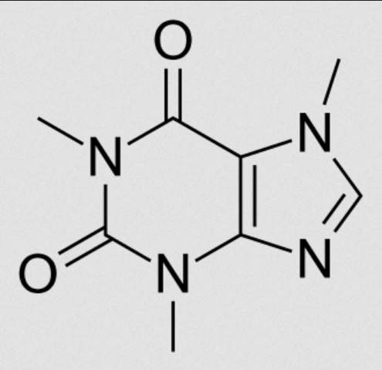
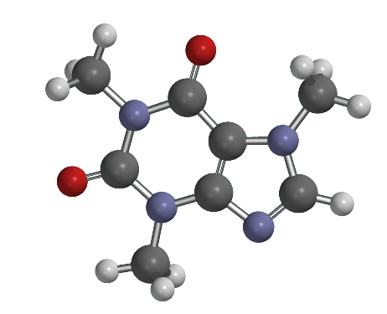
(b) Retinal
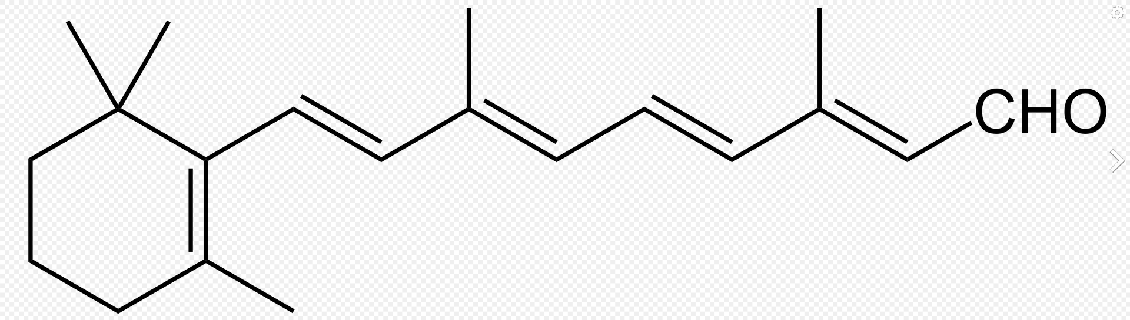
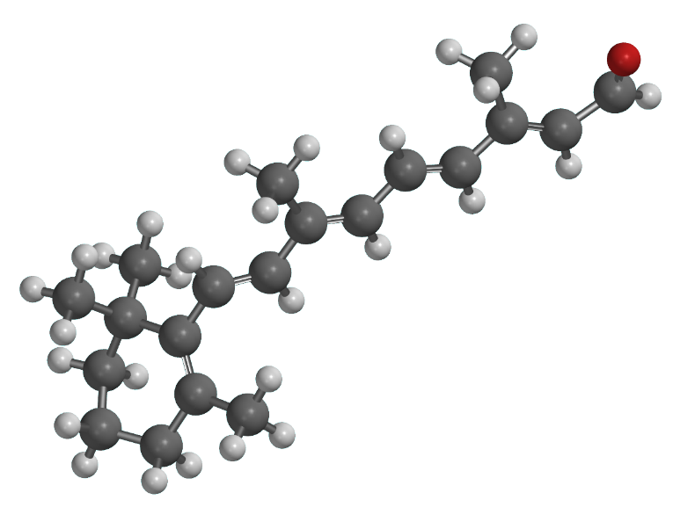
(c) Quinine
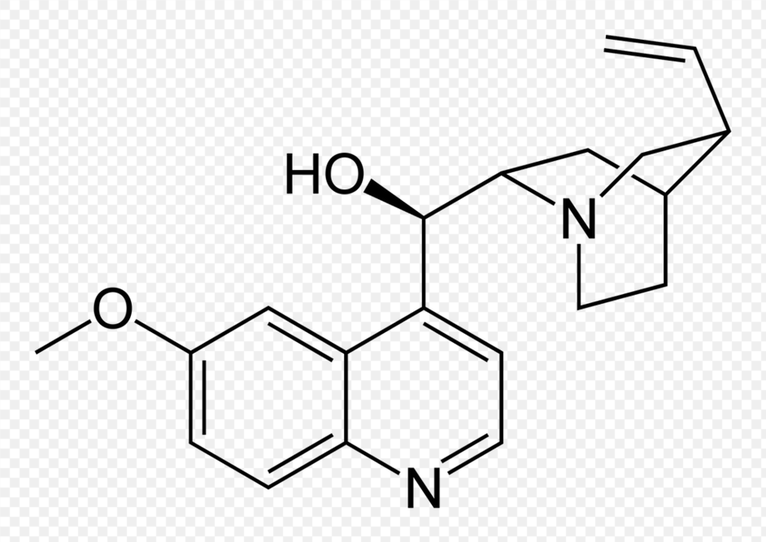
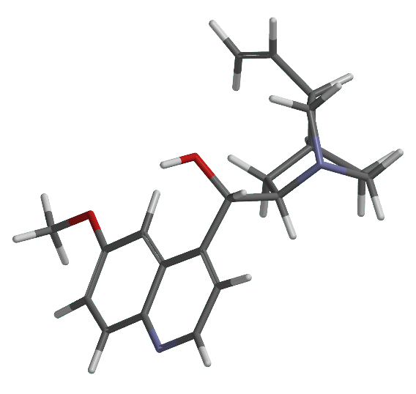

- Compare the accuracy of your calculation on IPs and EAs with various methods and basis sets. Why do some of the calculated EAs have very large errors? How to overcome the difficulty? (10%) Calculate the EA of Ar using standard and general basis sets. How close is your prediction to the experimental value (-1.0 eV)? (10%)
[Why do some of the calculated EAs have very large errors?]
Because the electronic cloud of anions distributes widely (especially for Noble gases, the additional electron goes to the next principal quantum number), there would have large errors without adding more diffuse function.

[How to overcome the difficulty?]
Calculate with additional diffuse function.

[Calculate the EA of Ar]
standard
Ar | Ar- | EA  (Hartree) | EA  (kcal/mol) | exp (kcal/mol) | error (kcal/mol)
-526.95530 | -526.81389 | 0.14141 | 88.7 | 23 | 65.7
gen
Ar | Ar- | EA  (Hartree) | EA  (kcal/mol) | exp (kcal/mol) | error (kcal/mol)
-526.96082 | -526.92624 | 0.03458 | 21.7 | 23 | -1.3
The general basis set have very close prediction with only -1.3 kcal/mol absolute error.

- What is the definition of Cartesian Gaussian? How many basis functions will be used in a calculation of a CH2CHF molecule with the 6-31+G(d,p) basis set (6D)? How many occupied and unoccupied orbitals are obtained after an HF calculation? (20%)
(1) definition of Cartesian Gaussian:
$$f_{GTO}=Nx^{i}y^{j}z^{k}e^{-Zr^{2}}$$
which i, j and k is zero or integer, Z is orbital exponent (Z > 0)，N is normalization constant

(2) how many basis function will be used the calculation:
51 printed in log file
(3) how many occupied and unoccupied orbitals:
CH₂CHF have 6+1*2+6+1+7 = 22 electrons, so there are 9 occupied orbitals and 2 unoccupied orbitals.
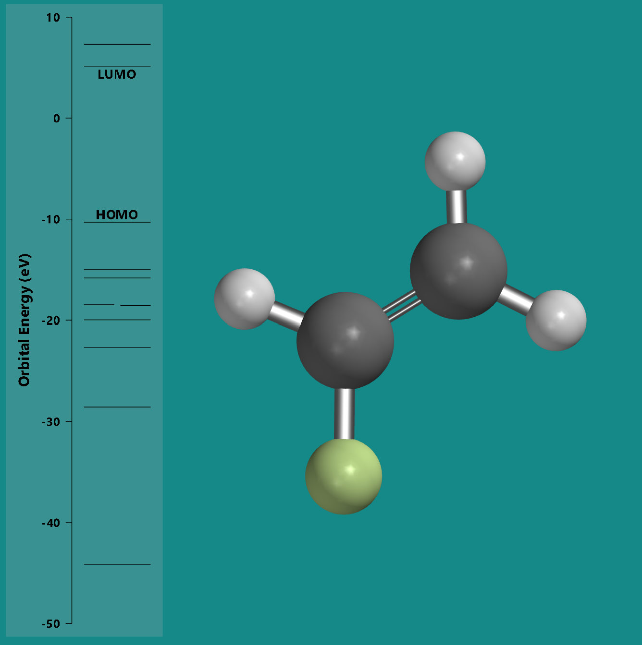
- Build the following (benzene)chromium tricarbonyl structure and estimate the Cr−C, C−O bond lengths and C−Cr−C bond angle at B3LYP/6-31G(d) level? (20%)

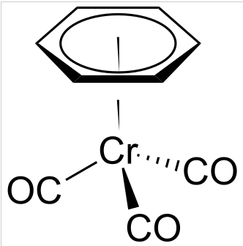
Cr−C = about 1.852 Å
C−O = about 1.160Å
C−Cr−C = about 89.9 degrees

5. Calculate the structure, vibrational frequencies, zero-point energy, and electrostatic map of formamide at MP2/6-31+G(d,p) level. Is the structure planar? (30%)

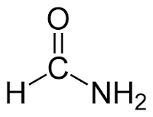
[Structure]
C=O = about 1.229 Å
C−H = about 1.099 Å
N−H = about 1.005 and 1.008 Å
C−N = about 1.363 Å

[vibrational frequencies]
Frequencies = 192.99, 566.31, 629.42, 1042.65, 1072.39, 1296.35, 1442.77, 1654.71, 1795.04, 3085.16, 3665.96 and 3820.52 (cm−1)

[ZPE]
Zero-Point Energy = about 28.9 (kcal/mol)

[Is the structure planar?]
No, because the dihedral is not equal to zero degree. If the symmetry is Cs (planar), it would have imaginary frequencies.

