Supplementary material
Calculations at TD B3LYP/6-311+G** level.

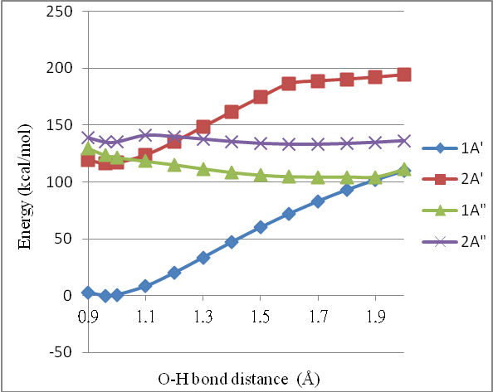
Fig. S1: The potential energies of the ground state and singlet excited states along the O-H bond distance of phenol at TD B3LYP/6-311+G** level.

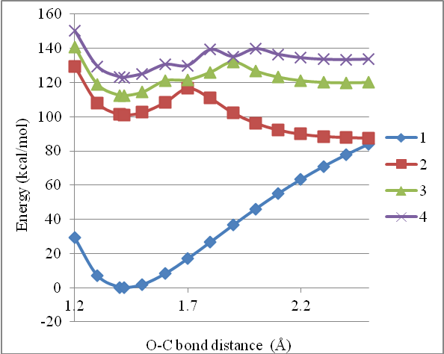
Fig. S2: The potential energies of the ground state and singlet excited states along the O-C bond distance of 2MOBA-1 at TD B3LYP/6-311+G** level (non-planar).

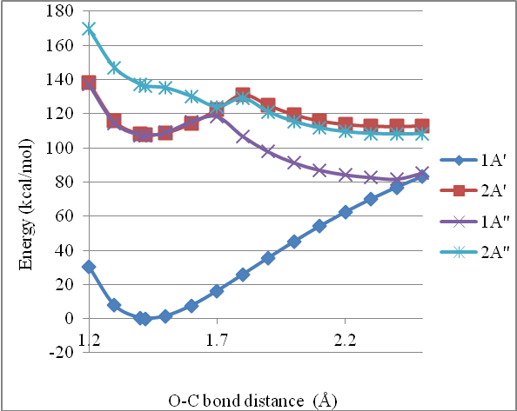
Fig. S3: The potential energies of the ground state and singlet excited states along the O-C bond distance of 2MOBA-1r at TD B3LYP/6-311+G** level.

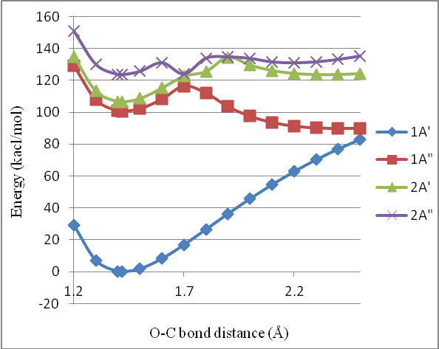
Fig. S4: The potential energies of the ground state and singlet excited states along the O-C bond distance of 2MOBA-2 at TD B3LYP/6-311+G** level.

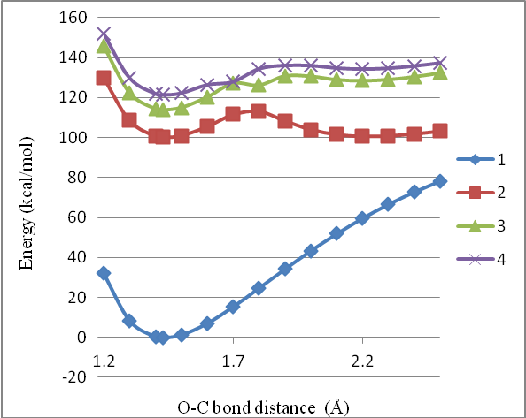
Fig. S5: The potential energies of the ground state and singlet excited states along the O-C bond distance of 2MOBA-3 at TD B3LYP/6-311+G** level (non-planar).

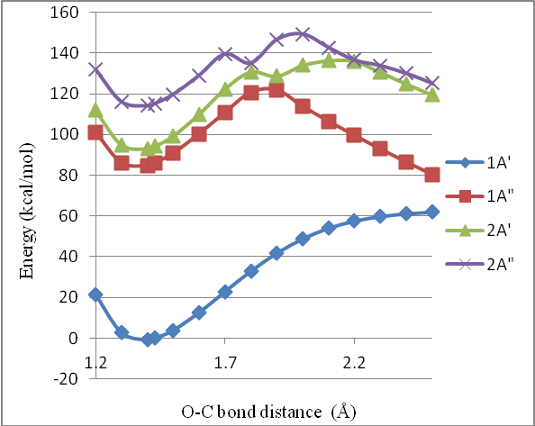
Fig. S6: The potential energies of the ground state and singlet excited states along the O-C bond distance of 2MOBA-3-Cs (Cs symmetry) at TD B3LYP/6-311+G** level.

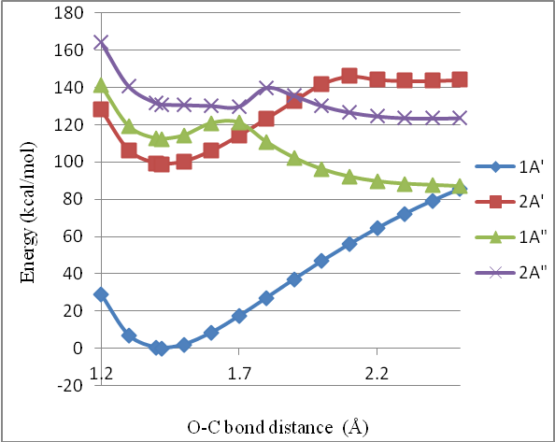
Fig. S7: The potential energies of the ground state and singlet excited states along the O-C bond distance of 3MOBA-a1 at TD B3LYP/6-311+G** level.

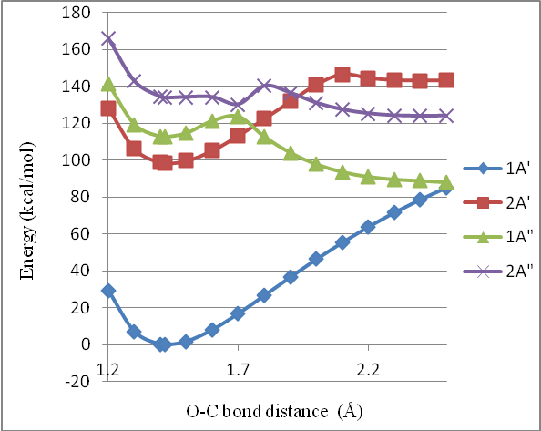
Fig. S8: The potential energies of the ground state and singlet excited states along the O-C bond distance of 3MOBA-b1 at TD B3LYP/6-311+G** level.

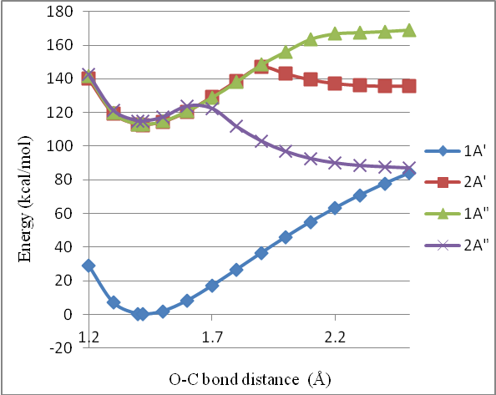
Fig. S9: The potential energies of the ground state and singlet excited states along the O-C bond distance of 4MOBA-1 at TD B3LYP/6-311+G** level.

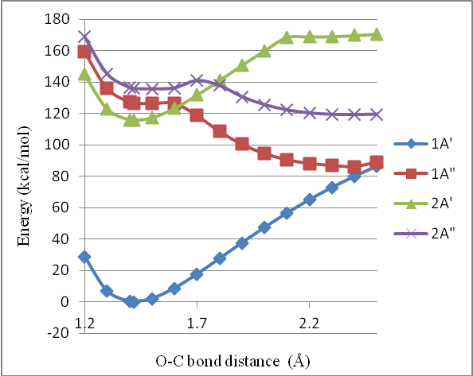
Fig. S10: The potential energies of the ground state and singlet excited states along the O-C bond distance of anisole at TD B3LYP/6-311+G** level.

